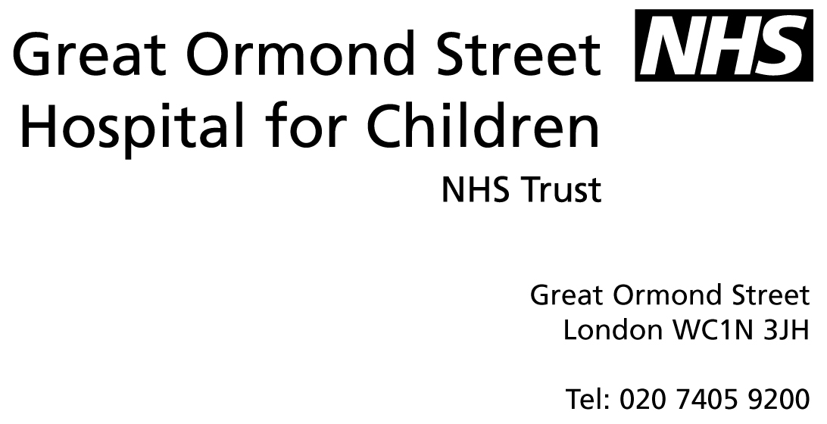
_

The National Study of Steroid Resistant Nephrotic Syndrome in Childhood

Letter of invitation

Dear Family,

Many thanks for taking the time to read this letter. You have recently consented to information about your child’s medical condition being uploaded onto a secure database known as RaDaR. This is to allow for the further study of rare kidney diseases, in this case, Steroid Resistant Nephrotic Syndrome/Focal Segmental GlomeruloSclerosis (SRNS/FSGS) in childhood.

A disease specific research group has been set up in Bristol University to study SRNS/FSGS and with permission from the RaDaR group we would like to invite you to participate in a study about SRNS/FSGS in childhood in the UK.

The principle aim of this study is understand why some children get SRNS/FSGS and how the disease causes the changes in the kidney that result in the nephrotic syndrome. We will also like to look at genes that are known to cause SRNS/FSGS and see how common they are in children in the UK with SRNS/FSGS.

At your next routine appointment with your kidney specialist they will talk to you about this study in a bit more detail and give you an information sheet that will explain what is involved if you participate.

You will be given time to chose whether you participate or not and it will not affect the level of care you receive if you do not participate.

The study has been approved by the North Somerset and South Bristol Research and Ethics Committee (09/H0106/80).

Many thanks for your time,

Yours sincerely,

Hugh McCarthy
Clinical Research Fellow
University of Bristol Academic Renal Unit

V1 11.11.2009

